
Grain items offered on menu are whole grain Skim and 1% milk offered daily.
NOVEMBER 2025

Mini Pancakes
Fresh Apple

Pizza Bagel
Fresh Apple

Mini Waffles
Fresh Apple

Open Ham & Cheese Bagel
Fresh Apple

Warm Apple Frudel
Applesauce Cup

Mini Glazed Donuts
Applesauce Cup

Large Chocolate Chip Muffin
Applesauce Cup

Soft Filled Cinnamon Toast
Crunch Bar
Fresh Sliced orange

Sliced Banana Bread
Fresh Sliced orange

French Toast Breakfast Bar
Applesauce

Sausage & Cheese Biscuit
Fresh Sliced orange

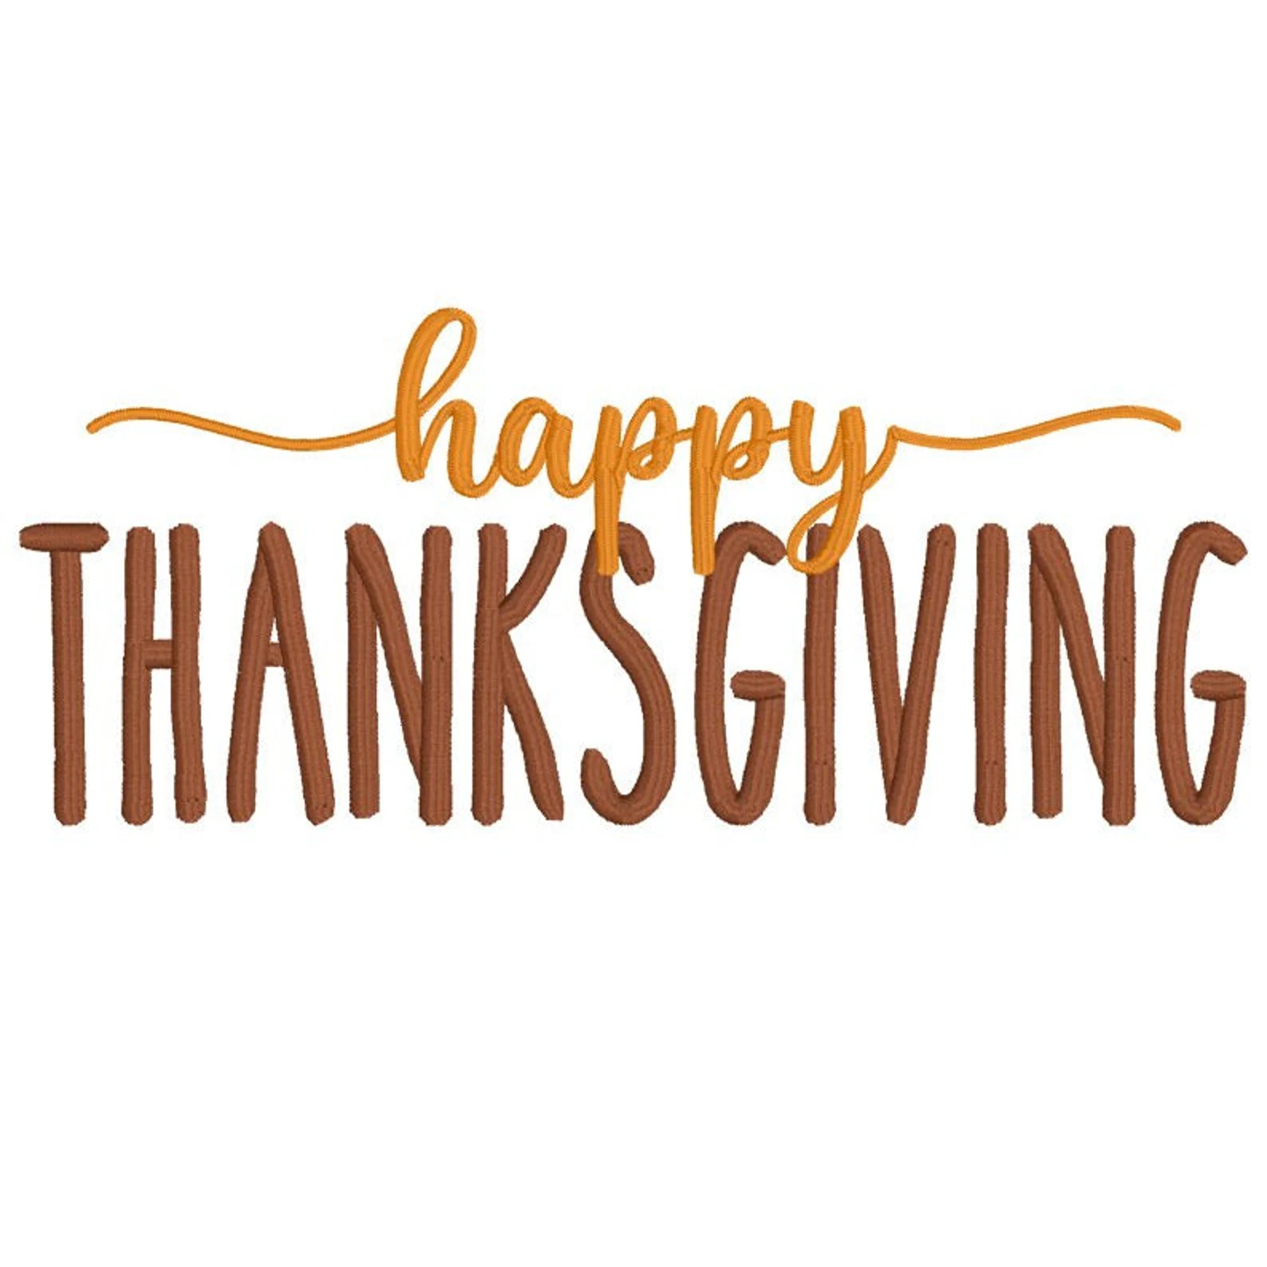

Veteran’s Day
No School

